
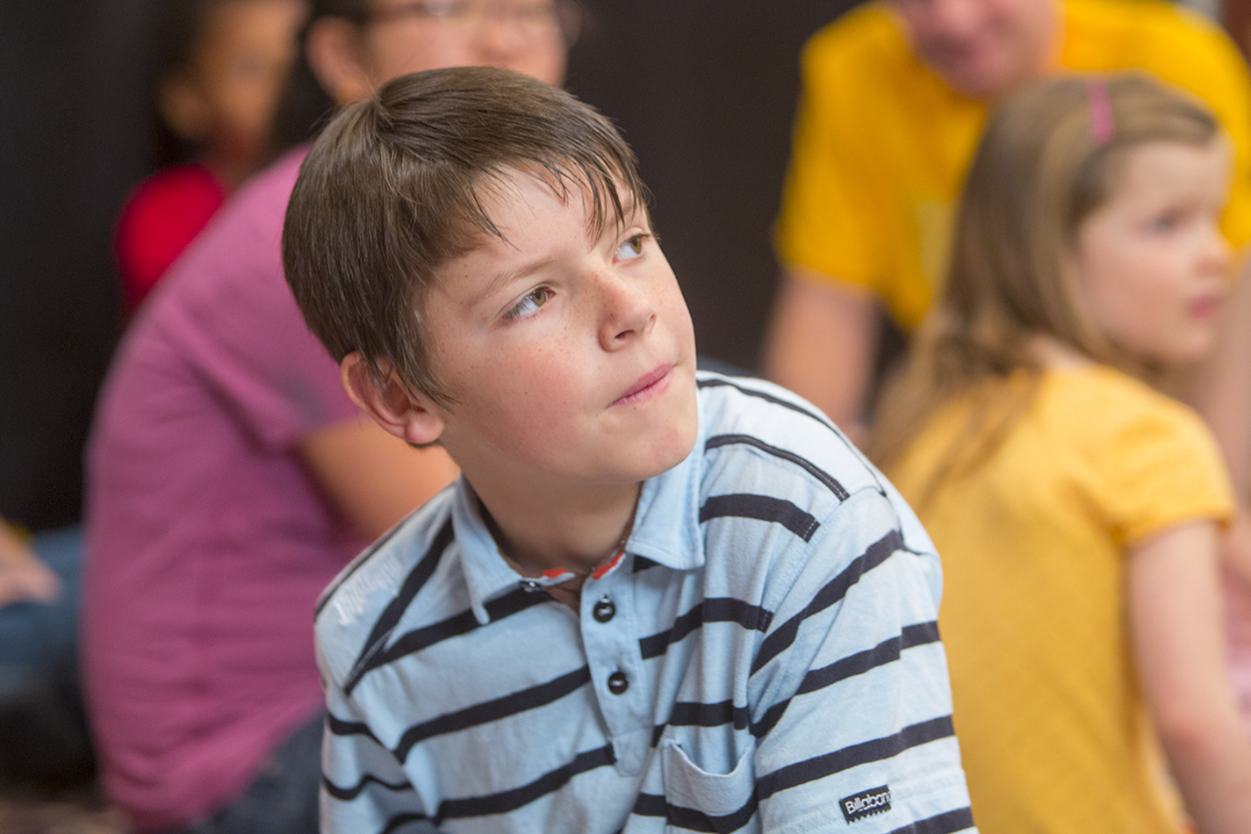

October 2019

“God gave you two ears and one mouth for a reason.” Like most parents, you’ve likely heard—or at least thought—this before. The symbolism rings true: Listening more than we speak shows that we care about people’s needs and feelings. Listening also helps us understand others better and grow closer to them.

That applies to our faith lives, too. Because listening is an integral component of worship and prayer, it’s vital for maintaining a strong relationship with our Creator and Savior. God speaks to us through his Word, through his answers to prayer, and through our fellow Christians traveling on this journey with us.

Being a good listener—to people as well as to God—is an acquired skill. Even adults need reminders and practice to remain alert, open, and attentive to one another and to God. That’s especially true these days, when many distractions and other “voices” threaten to pull us away from faithfully following our true Leader.

Faith becomes “sticky,” according to researcher Kara Powell, through give-and-take conversations among parents and children. That means it’s important to listen as much—or more than!—you talk. Kids’ questions and observations provide a window into their faith development and into how we can encourage continued growth.

So, put on your “listening ears” to discover even more auditory insights.

Listen Up!


POWERSOURCE
ASK JESUS:
1. To help build your family members’ listening skills and relationships.
2. To show you how to listen to and engage with God.
3. To keep you focused on God’s voice, not on all the competing voices from the world.

Compliments of the
Tracy SDA Church!

www.tracysdachurch org

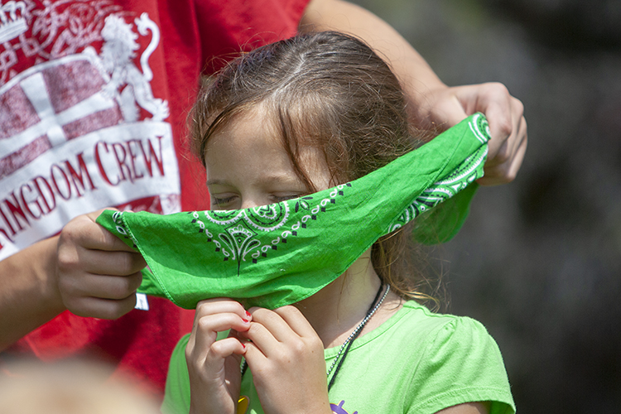
TEACHABLE
MOMENTS

The Master’s Voice
Set up an obstacle course and blindfold someone to be led through it. Also choose a leader. Say: Our blindfolded person must follow this leader’s voice to make it through the course. The leader will always give the correct directions, but the rest of us will loudly call out wrong directions to try to drown those out.
Give everyone a turn to be led. Then ask: How did it feel to be blindfolded and not know which voice to trust? How is this like or unlike trying to hear God’s voice in a chaotic world? What things can prevent us from hearing the quiet voice of God?
Read aloud John 10:2-5. Ask: How can we know which voice to follow? How can we become more careful listeners of God’s voice? What are some ways God helps us learn to hear his voice and speaks to us?
Say: Let’s ask God to help us listen carefully to his voice. Close in prayer.

Listening and Learning

Listening has a powerful effect on the person who’s listening as well as on the person who’s being listened to. It helps us make connections with one another, shows respect, and incites our curiosity. Listening well also makes us better speakers. We can communicate more effectively when we’ve taken the time—and remained silent long enough—to hear out someone else. Listening is just the first step, however. We also need to act on what we’re hearing and put our learning into practice. As James 1:22 (ESV) says, “Be doers of the word, and not hearers only”!

“Come to me with your ears wide open. Listen, and you will find life. I will make an everlasting covenant with you.” —Isaiah 55:3

Look & Listen Hide a small object and tell family members you’ll give them clues to find it. Play loud music and start saying clues without shouting. Afterward, discuss how the noise affected the ability to hear and how people overcame that. Read aloud (or summarize) 1 Samuel 3:1-21 and ask: “How did Samuel know when God was speaking to him? How can we learn to hear God’s voice?” Say: “Let’s remind each other to tune out earthly noises so we can hear God!”
Be Still For this exercise, allow adequate time between steps. Hand out paper and pencils. Read aloud Psalm 46:10 and say: “Think about what this verse means.” (Pause.) Say: “Close your eyes and listen for sounds nearby.” (Pause.) Say: “Now listen for God’s voice.” (Pause.) Say: “Write or draw what you feel and hear.” When everyone’s finished, discuss your experiences and how being still helps us hear God better.
Stop, Drop & Follow Read aloud (or summarize) Acts 9:1-20. Have family members act out being Saul. Shine a flashlight and say: “Drop to the ground! Saul couldn’t see, so close your eyes.” (Pause.) Say: “Now stand up and listen up!” Give a simple instruction, such as clapping hands, stomping feet, or repeating a phrase. Then have everyone open their eyes and stand up. Repeat, issuing a new command each time. Afterward, ask: “What was it like to listen to and follow directions when you couldn’t see? What did Jesus want Saul to do?” Say: “Jesus wants us to listen to him and follow him. Then we can tell others about Jesus so they can follow him, too!”
“I” Am Listening Give each person 10 marbles. Say: “Mingle and talk about your day—but without saying the word I. If you do, anyone who hears it gets a marble from you.” After five minutes, count marbles. Ask: “What was it like to avoid saying I?” Read aloud Philippians 2:3-4. Ask: “Why does God tell us to focus on others, not on ourselves? How does listening closely show that we care about other people?”
Actions Speak Volumes On index cards, write the names of famous Bible people (one per card). Take turns silently acting out what each is known for. Read aloud Ecclesiastes 3:7. Ask: “How did you know who those people were? Why do we often remember actions more than words? How can we combine our actions and words to tell about Jesus?”

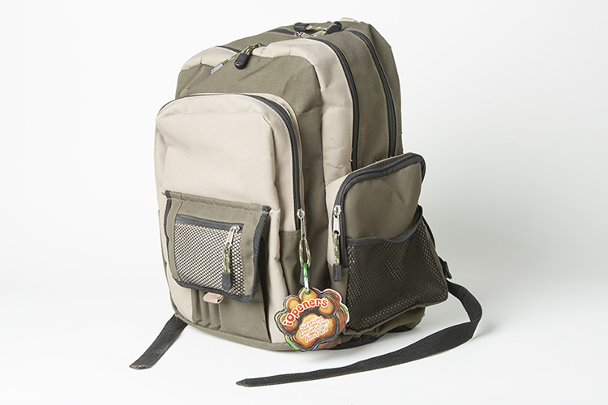

MOVIE

Title: Maleficent: Mistress of Evil
Genre: Adventure, Family, Fantasy
Rating: not yet rated
Cast: Angelina Jolie, Elle Fanning, Michelle Pfeiffer, Chiwetel Ejiofor
Synopsis: This live-action movie is Disney’s sequel to Maleficent (2014). When Aurora accepts Prince Philip’s proposal, her wicked fairy godmother forbids the marriage, saying, “Love doesn’t always end well.” Jolie said her title character goes “full wings, full horns, full crazy” in this film.
Our Take: Based on the trailer and plot, this movie promises to be dark and intense. Like most “family friendly” fare released in October, it has a supernatural focus that may make parents uneasy. Keep younger children away and use caution with older kids.
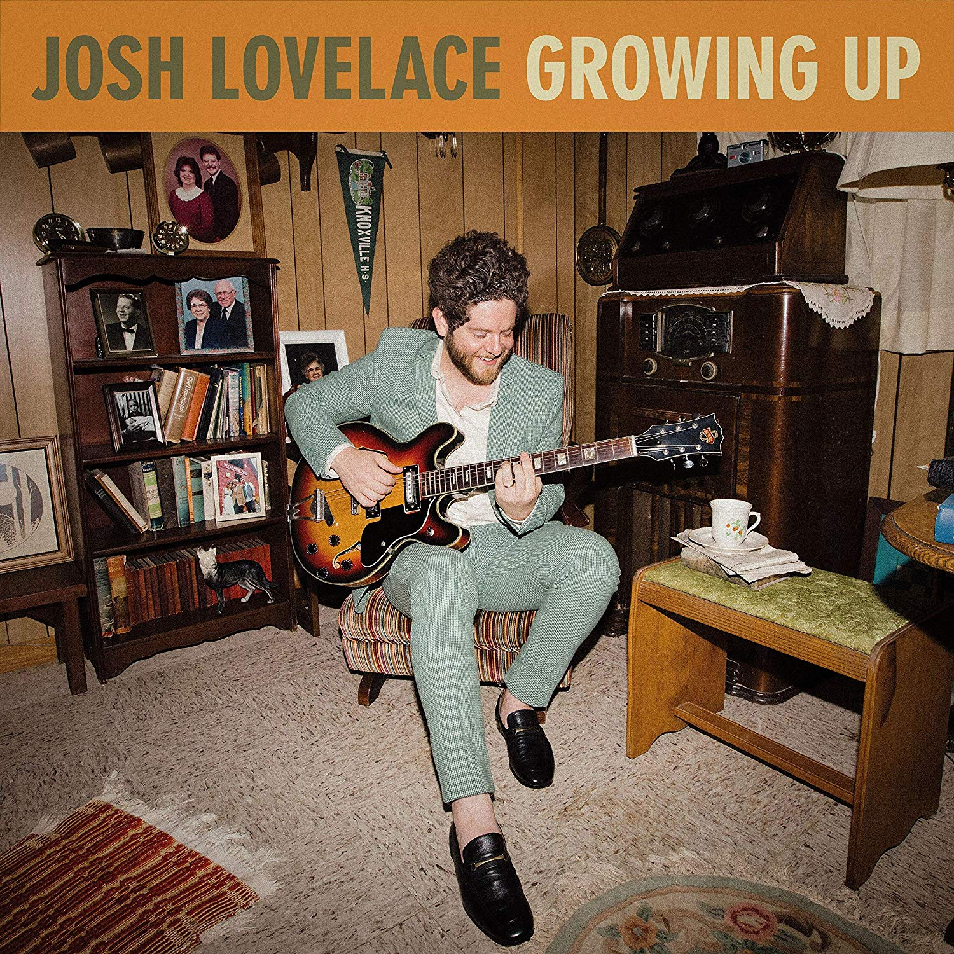
MUSIC

Title: Growing Up
Artist: Josh Lovelace
Synopsis: This is the second “family album” from Lovelace, a father and member of the pop-rock band NEEDTOBREATHE. As a longtime fan of children’s music, Lovelace wanted to create positive, reflective songs that spark conversations among people of all ages. His first family album was 2017’s Young Folk.
Our Take: The concepts and lyrics on this album are full of love and wonder. Lovelace encourages listeners to be kind and accepting, to cherish their time together as a family, and to remember that they aren’t alone. Although the album isn’t billed as Christian, Lovelace and his band have roots in the faith community.

MEDIA MADNESS

CULTURE
& TRENDS
Safer Students? Sales of bulletproof backpacks soared this fall, as back-to-school shopping coincided with several mass shootings. The pricey knapsacks are marketed as potential shields, though there’s little evidence they provide protection. Some experts fear the packs may increase kids’ anxiety. (various sources)

Don’t Mess With Halloween A petition to move Halloween to the last Saturday in October has morphed into an effort to add a National Trick or Treat Day on that Saturday. Groups trying to boost children’s safety ran into pushback from those who insist the holiday is fine as is. (USA Today)

QUICK STATS
Kid-Less for the Climate More than 450 people (80% of them women) have joined the new BirthStrike movement, pledging not to have children because of global warming. (ctvnews.ca)

Violence at Home Every year, one in 15 children is exposed to domestic violence, and 90% are eyewitnesses. A boy who sees his mother being abused is 10 times more likely to abuse a female partner as an adult. (ncadv.org, womenshealth.gov)

Games, Podcasts & Apps

Luigi’s Mansion 3
In this Nintendo Switch game, Gooigi, a green doppelganger, helps the timid hero navigate obstacles in a haunted hotel. Upgraded ghost-hunting equipment includes the Poltergust G-00 vacuum cleaner. ScareScraper mode is for multiplayer action.
The game, released on Halloween, is rated E.
Official Average Boy
Focus on the Family produces this podcast, which explores topics ranging from Christian stewardship and service to manners, friendship, and technology. Children and parents can listen to the entertaining episodes together and use them as springboards for valuable discussions. Best for ages 8 to 12.
Picture Dots
Designed by the New York Hall of Science as part of its Noticing Tools suite, this free app for ages 3+ builds curiosity and STEAM skills. After parents upload photos, young “content creators” can personalize them to tell stories, make and record sounds, find patterns, and more. Also available in Spanish.

This page is designed to help educate parents and isn’t meant to endorse any movie, music, or product. Our prayer is that you’ll make informed decisions about what your children watch, read, listen to, and play.

October

SUNDAY | MONDAY | TUESDAY | WEDNESDAY | THURSDAY | FRIDAY | SATURDAY
 |  | 1 | 2 | 3 | 4 | 5  10:45 am –VBS/Bible Adventures Program (Ages 5-12)
6 | 7 | 8 | 9 | 10 | 11 | 12  10:45 am –VBS/Bible Adventures Program (Ages 5-12)
13 | 14 | 15 | 16 | 17 | 18 | 19  10:45 am –VBS/Bible Adventures Program (Ages 5-12)
20  Family Fall Festival (1–4 pm) at Tracy Christian School (behind church) | 21 | 22 | 23 | 24 | 25 | 26  10:45 am –VBS/Bible Adventures Program (Ages 5-12)
27 | 28 | 29 | 30 | 31  Halloween

Saturday Mornings Cave Quest VBS/Bible Adventures’ Children’s Program (Ages 5-12) Each Saturday morning beginning at 10:45 am until 12:00 noon, our Bible Adventures program is designed to introduce kids to God in interactive and engaging ways through the Bible – not to
mention they have lots of fun! Each week’s themed program includes singing, team activities,

healthy snacks and getting kids into the Bible using the award-winning children’s “Hands On Bible”!
Parents/Guardians are also invited to observe the program anytime, and if you would like more information about our Bible Adventures’ Program or volunteering (let us know!), please contact Kimberly at 209-481-9205.
Free Nursery Care and Toddler Program – Every Saturday during our 11:00 am church service!
October’s Health Tip – October is the start of Fall weather and yummy pumpkin drinks, Halloween candy, sugary treats, etc. Now’s also the time to think about how important it is to take care of your teeth and gums! Taking good care of your teeth/gums offers a much greater reward than just a healthy smile. Research suggests your oral hygiene may also have an important impact on your overall health!
So during National Dental Hygiene Month, remember to take a look at exactly how good of a job you are doing with brushing your teeth and caring for your gums by taking a video of yourself while you are brushing. Why? One study found that people who recorded their toothbrushing sessions for 2 weeks increased both their accuracy and number of brush strokes! However, if you know you will never video yourself brushing … at least focus on brushing for 2 minutes to ensure you are brushing all of your teeth well and then finish up by flossing! Here’s to your healthy smile!

