
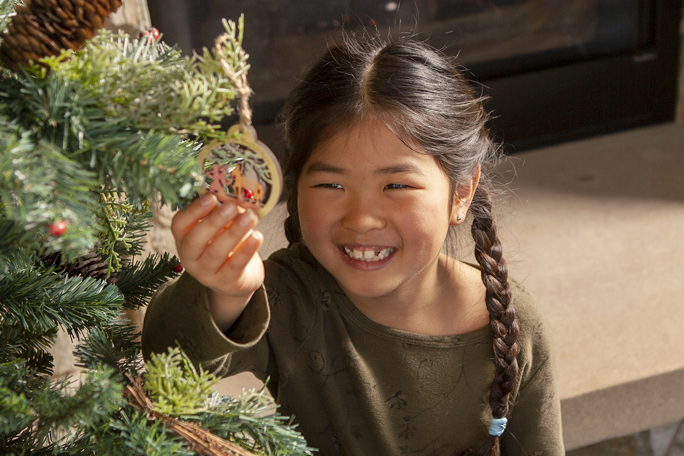

December 2019

Preparedness is a familiar and important concept for parents. Often it’s associated with physical safety: child-proofing a home, keeping emergency phone numbers handy, and planning ahead in case of natural disasters.

Preparation also plays a role in joyful occasions—from faith passages to developmental milestones. Throughout the years, parents make countless decisions and plans, offering guidance and support as their kids prepare to head out on their own someday.

During the weeks leading up to Christmas, a season known as Advent, followers of Jesus have the opportunity to prepare our hearts for his birth. That can be challenging, with all the hustle and bustle of the typical December. Advent also is a time to prepare for Jesus’ second coming, something we may not think about very often amid packed daily schedules.

Throughout Scripture—often in stories called parables—Jesus instructs us to stay alert and watchful. The day of his return, which is unknown to all but God, will appear like a thief in the night (1 Thessalonians 5:2). So, we are to remain awake, tell others about Jesus’ good news of salvation, and be ready to share our beliefs.

To help your children be spiritually prepared, put Jesus and faith in him at the center of your home—and your Christmas celebrations. Read on for more seasonal ideas for getting ready to welcome our Savior and King!

Christmas Reminds Us to Be Prepared


POWERSOURCE
ASK JESUS:
1. To help your family members prepare their hearts for the upcoming Christmas celebration.
2. To make you alert to ways you can share your faith during the holiday season.
3. To keep you ready and watchful for Jesus’ second coming.

Compliments of the
Tracy SDA Church!

www.tracysdachurch org


TEACHABLE
MOMENTS

Our Guiding Star
Hide a swaddled doll in a darkened room. Then lead family members through the room with flashlights (or phone lights) to search for the baby. Play several rounds, giving each person a turn to hide the baby and lead the search.
Read aloud Matthew 2:1-12. Say: A bright star led some followers to find baby Jesus, who was born to be the light of the world. It must have been so exciting to follow the star to Bethlehem to find baby Jesus!
Ask: In our game, how did you feel when you were following the light? How would the game have been different without flashlights?
Say: I’m glad we were prepared with these lights so we could find the baby. Let’s remember to follow the light of Jesus every day as we get ready for Christmas! Close in prayer, thanking Jesus for always guiding us with his light.

Jesus Is Coming!

The people of Jesus’ day expected him to be an earthly king who would overthrow the Romans and restore the kingdom of Israel. From our standpoint in history, we know that the baby Jesus grew up to become the Suffering Servant (see Isaiah 53), a sinless sacrifice who died in our place. One day, Jesus will return bodily to rule as King over all heaven and earth. But as Immanuel, or “God with us,” Jesus also remains always present with us, no matter what we’re facing. Remind children of that precious promise as Christmas approaches—and every day after!

“I have seen your salvation, which you have prepared for all people.”
—Luke 2:30-31

Guest Prep Brainstorm things your family does to get ready for guests. Discuss what you’d do differently if Jesus came to stay at your house. Read aloud Mark 1:3-4. Say: “John the Baptist told many people that Jesus was coming. We, too, can let others know what Christmas is about—our Savior’s birth.” Pray, asking God to bless your family’s plans for his Son’s arrival.
Holding onto Hope At breakfast, discuss each day’s Christmas-related plans. Talk about how anticipating this special time is like or unlike what Mary and Joseph hoped for as they waited for Jesus.
Preparing a Place Have children design place cards and decorate paper plates for a meal. Afterward, read Luke 14:12-24 and talk about how God loves each of us and invites us to a heavenly feast. Say: “While we’re preparing our hearts for Jesus, God is preparing a place for us in heaven.” Close in prayer, thanking God for each family member by name.
Waiting for the Promise Discuss why waiting is tough—and how it feels when a long wait is finally over. Read aloud Jeremiah 33:14-16. Say: “This prophet told people that the Messiah, Jesus, was coming. More than 500 years later, God’s promise was fulfilled.” Brainstorm promises you could make that might be worthwhile in 500 years. Say: “Knowing that God always keeps his promises helps us trust him while we’re waiting.”
“Spread” the News Set out sugar cookies, frosting, blunt knives, and sprinkles. While kids decorate cookies, discuss ways we can “spread” the good news about Jesus’ birth and add “sprinkles” of joy to people’s lives.

Nativity Copycats Encourage kids to follow the examples of people in the Bible: loving Jesus as Mary and Joseph did, praising Jesus as the angels did, telling others about Jesus as the shepherds did, and giving Jesus gifts as the wise men did.

Christmas Concert Let younger children ring bells, play music boxes, and dance to Christmas carols. Say: “Knowing that Jesus is coming makes us happy!”

The Big Picture On a long piece of paper, outline a Christmas design. Each day in December, spend a few minutes coloring in the details together. As the mural comes into focus, discuss how to stay focused on Jesus. Display the completed mural in a window.



MOVIE

Title: Spies in Disguise
Genre: Animation, Action, Adventure
Rating: PG
Cast: Will Smith, Tom Holland, Rashida Jones, Reba McEntire
Synopsis: This spy comedy with a Christmas release date is based on the animated short Pigeon: Impossible. After the world’s top spy accidentally swallows a young inventor’s gadget, he becomes a pigeon. In that feathered state, he must try to save the world from an evil mastermind.
Our Take: Kids will enjoy the shape-shifting and ingenuity in this movie, which is rated PG for action violence and rude humor. After watching it together, talk about making the most of tough situations and working with people who seem different from us.

BOOK

Title: How Much Is a Little Girl Worth?
Author: Rachael Denhollander
Synopsis: In this picture book geared toward ages 4 to 8, abuse survivor and advocate Denhollander emphasizes every child’s God-given value. Lively illustrations show girls of various races, accompanied by uplifting text such as: “You bear God’s image—mind, body, and soul—Lovingly made to be perfect and whole.”
Our Take: This book helps build up children’s esteem by pointing to God as their loving Creator: “He says you’re worth everything, even his Son.” Though aimed at girls, the message also is applicable to boys and even adults. With older children, you can tie in body-safety messages while reading about each person’s worth.

MEDIA MADNESS

CULTURE
& TRENDS
The VSCO Takeover VSCO has become more than just a photo-editing app. Now it’s also the latest label for Gen-Zers, specifically girls. Described as surfer-girl-meets-the-’90s, “VSCO girls” gravitate toward Birkenstocks sandals, little-to-no makeup, hair scrunchies, and Hydro Flask water bottles covered with hip stickers. (various sources)

Building Braille Skills To help blind and vision-impaired children learn Braille, LEGO created special bricks containing the raised-dot symbols. While playing, kids can boost their reading and number skills. Sighted friends also can participate, thanks to printed letters and numbers on each brick. This is the latest in a wave of inclusive toys. (kidscreen.com)

QUICK STATS
Overextended Though the federal government recommends putting no more than 7% of household income toward childcare, almost two-thirds of U.S. families (and 95% of low-income families) spend more than that. (time.com)

Picking Pronouns More than one-third (35%) of Gen Z-ers, born from 1995 to 2015, say they personally know someone who uses gender-neutral pronouns such as they and them. (Pew Research)

Games, Podcasts & Apps

Star Wars Jedi: Fallen Order
With another film release this month, “Star Wars”-themed items are sure to be in demand for Christmas. In this game, Padawan fugitives train to rebuild the Jedi Order before getting wiped out by the Empire. It’s rated T for Teen, so use caution.

Christmas Stories
This podcast from Focus on the Family is filled with seasonal activities, tips, and stories for all ages. Episodes encourage family members to share their favorite Christmas memories—and may even inspire you to begin some new traditions together.

Family Link
New from Google, this free app promises to help parents set “digital ground rules” for young device-users. Family Link encourages healthy decision-making, monitors usage, and suggests teacher-approved apps that parents can add directly to a child’s device.

This page is designed to help educate parents and isn’t meant to endorse any movie, music, or product. Our prayer is that you’ll make informed decisions about what your children watch, read, listen to, and play.

December

SUNDAY | MONDAY | TUESDAY | WEDNESDAY | THURSDAY | FRIDAY | SATURDAY
1 | 2 | 3 | 4 | 5 | 6 | 7  10:45 am –VBS/Bible Adventures Program (Ages 5-12)
8 | 9 | 10 | 11 | 12 | 13 | 14  10:45 am –VBS/Bible Adventures Program (Ages 5-12)
15 | 16 | 17 | 18 | 19 | 20 | 21  10:45 am –VBS/Bible Adventures Program (Ages 5-12)
22 | 23 | 24  Christmas Eve | 25  Christmas Day | 26 | 27 | 28  10:45 am –VBS/Bible Adventures Program (Ages 5-12)
29 | 30 | 31  New Year’s Eve

Saturday Mornings Cave Quest VBS/Bible Adventures’ Children’s Program (Ages 5-12) Each Saturday morning beginning at 10:45 am until 12:00 noon, our Bible Adventures program is designed to introduce kids to God in interactive and engaging ways through the Bible – not to
mention they have lots of fun! Each week’s themed program includes singing, team activities,
healthy snacks and getting kids into the Bible using the award-winning children’s “Hands On Bible”!

Parents/Guardians are also invited to observe the program anytime, and if you would like more information about our Bible Adventures’ Program or volunteering (let us know!), please contact Kimberly at 209-481-9205.
Free Nursery Care and Toddler Program – Every Saturday during our 11:00 am church service!
December’s Health Tip – With the Christmas holiday fast approaching (especially since Thanksgiving came a week later this year) and our “To Do” list in high gear … it is easy to get stressed and not be able to stay in the moment and enjoy the Christmas Season! To help keep your stress level under control and better enjoy the Season, below are some helpful tips from www.StressStop.com!

1. Make a list of what NOT to do. As you head into the holiday season there are probably numerous chores, errands and projects that don't need to be done now and can be put off until January when your schedule will open up. Whether it's cleaning up the garage, shopping for a new sofa (which wouldn't arrive in time for the holidays anyway) or painting the kid's bedroom, don't start any optional projects right now.

2. Streamline what you dislike and savor what you love.
We all have things we love to do at the holidays and things we wish we didn't have to do. If you love making potato latkes or getting the Christmas tree - set aside time and make an afternoon of it. Get the whole family involved if you want to or just savor this activity yourself. On the other hand if you dislike doing cards don't feel obligated to "keep up with the Jones." Just say no - or streamline the process - cut your list way down, get a simple card, sign it (No long notes!) and send it on its way.

3. Find the true meaning of the holidays. Whether it's attending services, donating toys and food, volunteering at a homeless shelter, visiting an elderly shut-in, or even watching IT'S A WONDERFUL LIFE, look for activities that give you an emotional and/or spiritual lift. Remember the word holiday is short for Holy day. Let this definition be a reminder of the true meaning of the season.

4. To experience joy: allow extra time. Time pressure kills joy. Be aware of how time pressure can turn a pleasurable activity, like shopping or even going to a party into an activity that loses its fun-factor. Whenever you're feeling rushed, chances are you'll wind up feeling crabby and stressed, too.

5. Make a list and check it twice. People are great at making lists but they rarely prioritize their lists. As a result, you wind up picking off low-priority tasks like vacuuming or raking leaves and not leaving enough time for high priority activities like spending time with family and friends. If the holidays seem hollow check your priorities and see if the things that are really important to you are at the top of your list.

6. Allow time for yourself. And finally, don't forget to allot some time every day (even if it's just a half an hour) to recharge your own batteries. You can't make anyone else happy if you are feeling miserable and stressed inside. Give yourself permission to go for walk, exercise, take a bath, listen to music, enjoy a leisurely cup of tea or do something just for the fun of it.
Bottom line: Build in extra padding into your busy schedule. If you think an activity will take an hour - allow at least two hours. We guarantee that if you follow just this one bit of advice, you'll experience more joy.

