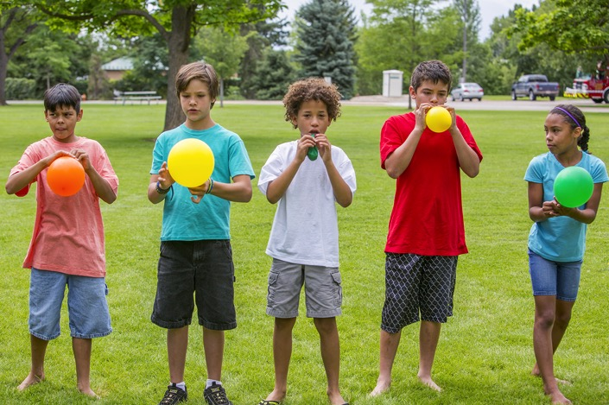
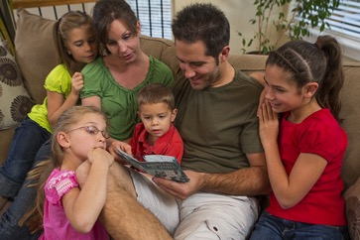

Compliments of the
Tracy SDA Church!

www.tracysdachurch.org

February 2020

Healthy trust levels with others set the foundation for how children experience social and emotional relationships later in life. When kids realize that God, their environment, and the people around them are trustworthy, they feel secure, hopeful, and optimistic.

Trust is also vital for spiritual development. Early experiences with parents and the church impact children’s perceptions of God. When kids feel safe and loved, they can trust that God loves them, too. From birth, you can help your kids develop trust through:

Trustworthy Relationships Children learn to trust you and other adults from their earliest years. Keep your promises and follow through. Take care to expose them to kind, nurturing people, from church friends to grandparents.

Trustworthy Environments Safe, engaging surroundings help kids trust that you’ll take care of them. Remember: Material possessions aren’t as important as people who provide consistency and comfort.

Trust-Building Activities Inject laughter and fun at home. Younger children especially feel secure when play is part of life—Peek-a-Boo and familiar songs are a great starters.

Faithful Foundations You create the basis for kids to build trust in God. Bit by bit, you empower them to trust in Someone who’s so much bigger than they are.

Read on for more trust-building ideas!

x

x

Teach Kids That God Is Trustworthy

POWERSOURCE
ASK JESUS:
1. To help you be a trustworthy caregiver and an example of God’s trustworthiness.
2. To reassure your children that God cares deeply for them and keeps all his promises.
3. To reveal his trustworthiness and goodness to your family.

That’s Impossible! Take turns trying to unwrap Hersey’s Kisses while wearing oven mitts. Read Matthew 19:26 and ask: “What things can God do that are impossible for us to do? What are you facing that seems impossible? How can we trust that God has all these things in his hands and takes care of them for us?” Close with a group hug and enjoy some Kisses.

Unseen Blessings Beforehand, gather paper cups, put a few drops of food coloring in each, and cover the drops with a heap of baking soda. Ask: “What troubles do you face? Draw or write them on the outside of your cup.” Read aloud 2 Corinthians 4:18. Say: “If we focus too much on our outside troubles, we might forget to trust that God is doing good things we can’t see.” Pour a few drops of vinegar in each cup so the color appears. Ask: “What can we focus on instead of troubles? How can we trust God even though we can’t see him?”
Multiplied Beforehand, cut 5-inch squares of tissue paper (yellow, pink, and blue) so there are more squares than people. Cut yellow stacks into bread-slice shapes, pink stacks into hearts, and blue stacks into fish shapes. Say: “Jesus cares for our bodies and our hearts.” Read Mark 6:34-44. Give each person one bread and one fish. Point out all the extras. Say: “Jesus did a miracle! People had food for their bodies and learned about Jesus’ love.” Give each person a pink heart. Ask: “What did you think about all these leftovers? How can we trust Jesus to give us more than we need?”

Trust Walk Take turns leading one another around the house or yard. The person being led should wear a blindfold or keep his or her eyes closed. First, have the guide hold the partner’s elbow but say nothing during the walk. Then have the guide shout instructions from far away. Afterward, discuss what makes trusting easy or tough.

Molded by God’s Hands Give each person a lump of modeling clay. Say: “Think of something you want to make. Then we’ll try three different ways to make it.” First, have people stare at their clay. Then have them try to mold it with bare feet. Finally, let them use their hands. Talk about what worked and what didn’t, and why. Read aloud Isaiah 64:8. Ask: “How does God mold us?” Say: “We might think of God as being far away, but if he is a potter and we are the clay, then God is as close as our skin. We can trust God’s promise that he is always with us and is active in our lives!”
As children grow, their views of God and his trustworthiness develop.
Ages 2 to 4 Preschoolers identify God as having a human form and traits. These traits most likely resemble those seen in key adults in kids’ lives.
Ages 5 to 8 Fear of the unknown prompts kids to want to believe in a God who’s all-powerful, all-knowing, and omnipresent. Their grasp of God’s trustworthiness depends on how adults express these qualities to them.

Ages 9 to 12 Older children’s perception of God can range from a legendary superhero to a living, spiritual being—often like their own father.

TEACHABLE
MOMENTS

Seeing the Full Picture
You’ll need a Bible, paper, washable paint (at least three colors), and paintbrushes. Say: Think of a time when things felt ruined because they didn’t go how you expected. Have each person crumple a piece of paper into a ball. Ask: How did you react? Let people each choose one color to paint their paper ball while answering.
Carefully open the balls to view the paintings. Say: Now think of a time you were confused or scared. Have people crumple the papers again and use a different color to paint the balls while sharing. Then open the papers. Say: Think of a time you felt alone. Have people crumple the papers and use a third color to paint while sharing.
Read aloud 2 Corinthians 4:8-10. Ask: How could those difficult times be better, knowing that Jesus is with us and understands? Open the papers to see the finished paintings. Say: God uses tough times to show us his glory—and to help us trust him. Have faith in God’s full picture!

Trust Develops Over Time

“Lead me by your truth and teach me, for you are the God who saves me. All day long I put my hope in you.”
—Psalm 25:5

MOVIE

Title: Sonic the Hedgehog
Genre: Action, Adventure, Family
Rating: not yet rated
Cast: Jim Carrey, James Marsden, Ben Schwartz, Tika Sumpter
Synopsis: This long-delayed movie based on Sega’s video-game franchise features a blue hedgehog with super-speed that’s in high demand. After accidentally causing a power outage, Sonic hides in Montana, where a sheriff tries to shield him from the government and an evil scientist.
Our Take: Even non-gamers will be drawn to this heavily marketed film. Sonic explores ways to harness his unique powers to help his friends. Use that concept to discuss individual talents and how we can use them in positive, God-honoring ways.
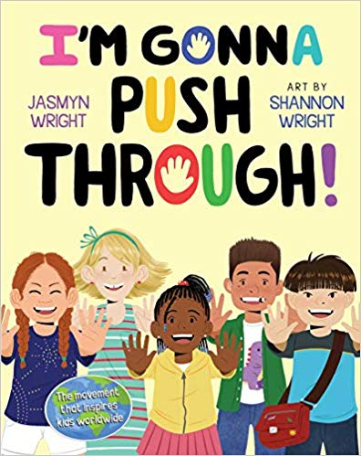
BOOK

Title: I’m Gonna Push Through!
Author: Jasmyn Wright
Synopsis: Wright, who taught elementary school in disadvantaged neighborhoods, wanted her students to feel empowered and excited to learn. After her #PushThrough movement went viral, Wright became a global speaker who spreads messages about self-worth, strength, grit, resilience, and overcoming adversity.
Our Take: This uplifting, inclusive picture book encourages children to recognize and build on their own strengths—and also to build up others. Wright inspires kids to aim high and keep reaching for their goals. While young people will benefit from these messages, they also need to hear that God is their source of strength and their help during times of trouble.

CULTURE
& TRENDS
Keeping Kids on “Track” Thanks to technology, parents now have many options for keeping tabs on their children. With a $25 washable patch (and a free app), B’zT helps pinpoint a child’s location within a 100-foot range. The mom-founded company also offers tracking apparel, which some schools are using. (time.com)

Unisex Goes Universal A parenting trend that’s on the rise is embracing gender-neutral names, nurseries, toys, playdates, haircuts, and even pronouns. Some parents striving for gender-neutrality use the pronoun “they-by” to refer to an unborn child. (various sources)

QUICK STATS
The Parenting Workout Don’t “sweat it” if you miss an exercise class (or two). A study of 1,000 moms and dads of kids ages 3 to 6 finds that typical parenting tasks burn 1,478 calories daily—the equivalent of 1,179 burpees! (Wren Kitchens)

Going Vegan One of every 12 U.K. parents raises their kids as vegan. Plant-based food sales are soaring in the U.S., too. (various sources)

In Need of a Boost Between ages 8 and 14, girls’ confidence levels drop by 30%. In that same time period, girls’ confidence that other people like them drops 46%. (YPulse)
Best Friend Forever
Though this Nintendo Switch role-playing game has a childlike look, it’s rated T for Teen and has a grown-up twist. The title, released on Valentine’s Day, is a pet-care simulation combined with dating adventures. Aided by furry critters, players explore an active singles scene.
5 Minutes With Dad
This upbeat, kid-hosted podcast covers a range of topics—from seasonal fun and hobbies to fears and family bonds. A father and his two kids engage in interesting chats that the whole family—including children as young as 4—will enjoy. The topics are sure to inspire continued discussions.
S’moresUp
With this highly rated app, families can stay organized and simplify chore assignments. Tasks and healthy habits are assigned a value and can add up to rewards (or charitable donations). Family members can share and sync calendars, so this works best with older kids who have phones.

This page is designed to help educate parents and isn’t meant to endorse any movie, music, or product. Our prayer is that you’ll make informed decisions about what your children watch, read, listen to, and play.

MEDIA MADNESS

Games, Podcasts & Apps

February

SUNDAY | MONDAY | TUESDAY | WEDNESDAY | THURSDAY | FRIDAY | SATURDAY
1
10:45 am –VBS/Bible Adventures Program (Ages 5-12)
2 | 3 | 4 | 5 | 6 | 7 | 8  10:45 am –VBS/Bible Adventures Program (Ages 5-12)
9 | 10 | 11 | 12 | 13 | 14  Valentine’s  Day! | 15  10:45 am –VBS/Bible Adventures Program (Ages 5-12)
16 | 17  Presidents Day | 18 | 19 | 20 | 21 | 22  10:45 am –VBS/Bible Adventures Program (Ages 5-12)
23 | 24 | 25 | 26  Ash Wednesday | 27 | 28 | 29  Family Sabbah in the Sanctuary!  Leap Day

Saturday Mornings Cave Quest VBS/Bible Adventures’ Children’s Program (Ages 5-12) Each Saturday morning beginning at 10:45 am until 12:00 noon, our Bible Adventures program is designed to introduce kids to God in interactive and engaging ways through the Bible – not to
mention they have lots of fun! Each week’s themed program includes singing, team activities,
healthy snacks and getting kids into the Bible using the award-winning children’s “Hands On Bible”!

Parents/Guardians are also invited to observe the program anytime, and if you would like more information about our Bible Adventures’ Program or volunteering (let us know!), please contact Kimberly at 209-481-9205.
Free Nursery Care and Toddler Program – Every Saturday during our 11:00 am church service!
February’s Health Tip – February is American Heart Month! Here are some heart-healthy tips from Pulse!
HEART HEALTHY DIETS
Getting enough physical activity is key to good health, but so is a healthy diet. A heart healthy diet is one that’s low in saturated fat and cholesterol, and high in fiber. Here are some tips to make the most of a heart healthy diet.
- Use water or a small amount of vegetable oil to sauté vegetables. Olive and canola oils are best. Avoid frying, especially deep-frying. Other heart-healthy cooking methods include poaching, steaming, roasting, baking and boiling.
- Don’t forget the fiber! Fiber helps remove cholesterol from the blood, which is why it’s such an important part of a heart-healthy diet. Choose whole grain breads and cereals and eat plenty of fruits and vegetables (skin and all) and you’ll have a healthier heart. Oats, carrots, fruits, and beans are especially high in the kind of fiber that lowers cholesterol.
- Be smart when you eat out. A heart-healthy diet does not have to be difficult when finding something good to order in a restaurant, but with a little bit of smarts, you can do just fine. Choose stir-fried entrees, steamed vegetables and whole grain pasta with tomato sauce. Ask for potatoes without butter or cheese, and avoid creamy soups and sauces. Ask for salad dressing on the side along with some lemon wedges to make the dressing go further. Lemon also makes food taste saltier, so you won’t need that salt shaker either (another benefit for your heart).
- Love your fruits, vegetables and grains! They contain fiber, vitamins and minerals!
- Limit your animal products. Cholesterol is only found in animal products (meat, eggs and dairy), so vegans do not need to worry about cholesterol in the foods they eat.

