
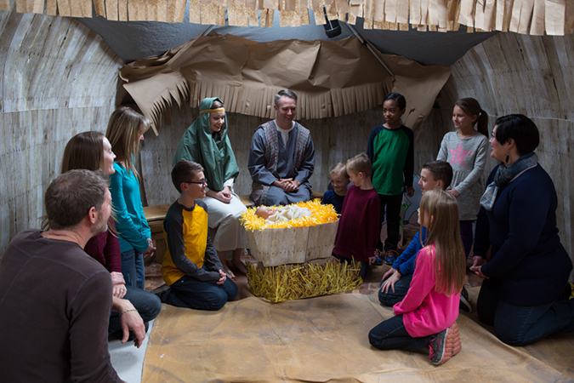

December 2020

Despite Christians’ efforts to honor the true meaning of Christmas, each December we must do battle with our consumer-oriented culture. The temptation to overindulge our children isn’t limited to the holiday season, either. All year long, kids are bombarded by ads for “must-have” items. Parents often give in, either because they can or because they don’t want their kids to feel deprived or left out.

From a spiritual standpoint, materialism shifts our priorities and dependence from God and heavenly things to what the world offers. From a developmental standpoint, overindulged children are less able to cope with stress, often lack self-control, and are at risk for being self-centered and depressed, researchers say. As the Christmas season approaches, keep these tips in mind.

Don’t rely on gifts as substitutes. Children desire time with you and emotional security. Deep down, they want relationships more than things.

Emphasize the importance of nonmaterial values. Prioritize spending time together as a family, whether you’re engaged in experiences and activities or spending quiet time at home. Watch the example you set regarding shopping and spending.

Help children explore their values. Instead of just saying “no” to every request, use the moment to discover what’s important to kids.

Teach Children What to Treasure


POWERSOURCE
ASK GOD:
1. To bless your family’s Christmas preparations and reflections.
2. To help your children feel satisfied with what they have.
3. To show your family the value of spiritual things rather than material things.

Compliments of the
Tracy SDA Church!

www.tracysdachurch org

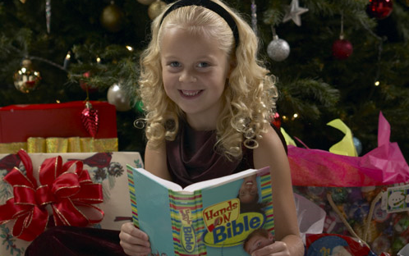
TEACHABLE
MOMENTS

The Greatest Gift

Beforehand, wrap a small gift for each family member. (Choose a variety of items that anyone would enjoy.) Sit in a circle and give each person one gift to hold.

Say: As I read the Christmas story, pass your gift to the person on your right every time I say “God,” “Lord,” or “Jesus.” When I’m done, I’ll say “amen,” and you’ll keep the gift you’re holding at that time.

Read aloud Matthew 2:1-12; Luke 1:26-38; and Luke 2:1-20. Then say “amen.” Have family members hold their gifts while you ask these questions: What did you have to do to receive the gift you have? What did we have to do to receive the gift of Jesus? What is most exciting to you about the Christmas story, and why?

Say: Jesus is the greatest gift of all! He freely gave his life for us out of love. Because of Jesus, we’ll live forever with him—and so will everyone else who loves him.

Close in prayer and open your gifts.

Nurture Generous Hearts

Jesus gave us the best guidance for living in a culture that overflows with materialism. In Matthew 6:33 (NLT), he challenges us to “seek the Kingdom of God above all else, and live righteously, and he will give you everything you need.” When we trust Jesus to provide, we can be generous and find joy in giving to others. Helping children develop a heart of gratitude is the best cure for a sense of entitlement. Gratitude moves the focus off ourselves so we can consider other people’s needs and act generously in response. Start by talking with your children about sharing. Then discuss why God wants us to be generous—and how sharing our blessings with others becomes a blessing for them. Try these ideas to nurture generosity and a giving spirit this Christmas.

“Store your treasures in heaven …
Wherever your treasure is, there the desires of your heart will also be.”
—Matthew 6:20-21

Hearts for Jesus Make a big stocking with the name “Jesus” in glitter. Let children make felt or paper hearts with their names on them and give their “hearts” to Jesus. (After all, that’s what he wants the most at Christmas!)

12 Days of Serving As a family, come up with 12 acts of service you can perform together during December. For example, shovel snow for a neighbor, donate extra blankets to a homeless shelter, and deliver cookies and hot cocoa to homebound senior citizens.

Try Tithing When children receive money for Christmas, have them use 10 percent to help someone else, whether they donate it or buy a small gift. Together, keep a journal detailing how children use that 10 percent—and see how the blessings add up!

Adopt a Family Purchase gifts and a holiday meal for a family in need. Then deliver everything on (or right before) Christmas Eve. You can do this anonymously.

All-Night Anticipation Curl up in sleeping bags beneath your tree on Christmas Eve. Before going to sleep, talk about what Mary and Joseph experienced on the journey to Bethlehem and in the stable. Before opening gifts in the morning, emphasize that Jesus is the first—and best—Christmas gift.

Baby Blessings Older kids can throw a baby shower (complete with birth announcements!) for Jesus and then donate items to a local crisis-pregnancy center.

Anonymous Angels On Christmas morning, have family members draw names. During each of the next 12 days, angels should anonymously do something special for their person (do a chore, leave a note or drawing, make a treat, etc.). On January 6 (Epiphany), have an Angel Party and reveal your identities. Serve angel food cake and discuss what it was like to bless others—and to be blessed by others.

Bearing Gifts Fill lunch sacks with small treats and tape them shut. Read aloud Matthew 2:1-12 and say: “After Jesus was born, wise men traveled a long way to bring him gifts. Let’s pretend to be wise men and camels!” Take turns being wise men who guide camels on all fours—carrying a sack on their back. Then talk about what gifts the wise men gave Jesus and what gifts we can give him.

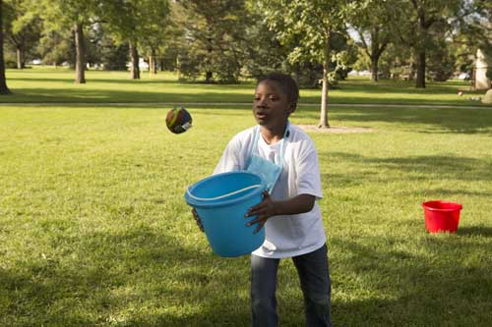
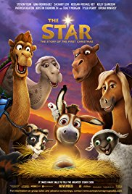
MOVIE

Title: The Star
Genre: Animation, Adventure, Comedy
Rating: PG
Cast: Tyler Perry, Oprah Winfrey, Kristin Chenoweth, Zachary Levi
Synopsis: A brave donkey yearning for adventure teams up with some eccentric stable animals. When the new friends follow a star, they become unlikely heroes of the first Christmas.
Our Take: This major Sony Pictures release includes lots of big-name talent, including a title song by Mariah Carey. Based on the trailer, the movie seems to offer more comedy and animated antics than religious insight. It is refreshing, though, to have a holiday release that actually focuses on the reason for the season—Jesus.

book

Title: Malala’s Magic Pencil
Author: Malala Yousafzai
Synopsis: The 20-year-old Nobel Peace Prize winner, who advocates for human rights and education, offers inspiration in this new picture book. While sharing her vision for equality and opportunity, she encourages young readers to change the world.
Our Take: Despite Malala’s experience surviving an attempted murder, this book remains age-appropriate for kids ages 4 to 8. There’s a suggestion of danger and hardship, but Malala’s message about educational ideals and the goodness of people is positive. Older kids may wonder what the author endured, and the book may provide a great opportunity to discuss the basics of Christian faith versus other faiths.

MEDIA MADNESS

CULTURE
& TRENDS
An Eye-Opener Spending more time playing outdoors has a protective effect on children’s eyesight, say researchers. Lots of exposure to outdoor light may also reduce kids’ chances of needing glasses for nearsightedness. (cnn.com)

Moods Are Catchy Children whose friends deal with bad moods are more likely to report being in bad moods themselves, according to a new study. The opposite is true for children whose friends are generally happy. (time.com)

QUICK STATS
“Spoiled” Alert! 46% of parents say they’ve gone into debt buying something their children want. (cnbc.com)

Tipping the Scales The number of obese children and teens worldwide now tops 124 million. That’s more than 10 times the number from four decades ago. (The Lancet)

Pardon Me About half of parents say they’re interrupted by their smartphones at least three times a day while talking with their kids. These interruptions contribute to negative behavior among children, research reveals. (telegraph.co.uk)

Games, Sites & Apps

Anaxi
In this lighthearted card game, which won a “best family fun” award, players make creative connections between words. The goal is to brainstorm people, places, and things that have qualities in common. Answers can be challenged. For ages 8 and up.

AutismHwy.com
This site, launched by the mother of an autistic boy, features fun games for children who are on the autism spectrum. It’s also filled with lots of helpful information for parents, including a blog, articles, resources, events, and specialists. Users must create an account to access site material.

Leela Kids
This free educational app for kids ages 3 to 15 curates podcast content based on topics and age groups. Topics range from science and space to music and animals. Kids and parents can rate and share any episode or story. Parents can hide certain age categories as desired.

This page is designed to help educate parents and isn’t meant to endorse any movie, music, or product. Our prayer is that you’ll make informed decisions about what your children watch, read, listen to, and play.

December

SUNDAY | MONDAY | TUESDAY | WEDNESDAY | THURSDAY | FRIDAY | SATURDAY
 |  | 1 | 2 | 3 | 4 | 5  11:00 am Sermon through Streaming (church website)
6 | 7 | 8 | 9 | 10 | 11 | 12  11:00 am Sermon through Streaming (church website)
13 | 14 | 15 | 16 | 17 | 18 | 19  11:00 am Sermon through Streaming (church website)
20 | 21 | 22 | 23 | 24  Christmas Eve | 25  Merry Christmas! | 26  11:00 am Sermon through Streaming (church website)
27 | 28 | 29 | 30 | 31  New Year’s Eve!

We miss the kids! When we resume meeting together again for a full service we will be once again providing our Saturday Morning VBS/Bible Adventures’ Children’s Program (Ages 5-12) - When we get past this period of time and are able to worship indoors again, we are planning to resume our Saturday morning program beginning healthy snacks and getting kids into the Bible using the award-winning children’s “Hands On Bible”!

December’s Health Tip – It’s that time again where the average person gains 7 pounds between Thanksgiving and New Year’s Day (1 pound per week) because of the additional calories consumed. In addition, we are all challenged with the COVID 5 to 15 lbs. we have been battling to keep off since we’re all at home more and cooking!

Remember, it only takes 3,500 calories to make a pound – which calculates to an average of 500 extra calories a day (ie, 2 cookies, a slice of cheesecake, a nice slice of cake and so on…). It doesn’t take much to eat an additional 500 calories a day unfortunately! Remember to plan your eating by writing down what you are eating each day to keep track of snacks, etc., drink plenty of water and get 7-8 hours of sleep each night. Also, try to include a daily exercise program whether it be out to a video or streaming program, brisk walking, walking in place while you watch TV, etc. to help you stay strong and healthy. Stay on guard … your body is depending on it! ☺

