
February 2021

James 3 tells us that our tongues can do quite a bit of damage. Name-calling, bickering, whining, and put-downs tear people apart. But, our tongues can also be used for good. They have the power to heal, encourage, and restore relationships. This is especially important during these stressful times when we can become impatient quickly. Our tongues can speak words of praise to God, too.

Here are some helpful reminders for using words in a positive way:

- Set an example by using appropriate, uplifting words and by apologizing when you mess up. Little ears are always listening—even before children can talk—so choose your words wisely.

- Know when to stop talking. Proverbs 10:19 says, “Too much talk leads to sin. Be sensible and keep your mouth shut.” Help children understand the importance of stopping to think before speaking. When in doubt, it’s always better to seal your lips than to say something you might regret.
- It’s confusing and irritating to kids when their parents set rules against swearing but don’t follow them. Avoid that double standard by modeling how to censor your words—especially when you’re upset.

- Talk frequently about Jesus and his love. When you and your family stay focused on Jesus—the Word—then your mouths and lives will bear good fruit for him.

Show Love With Your Words

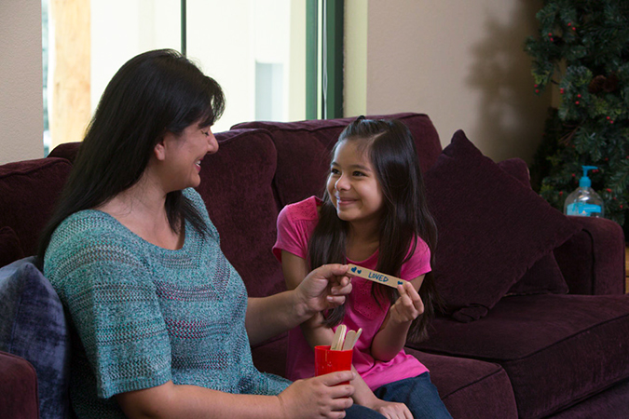
POWERSOURCE
ASK GOD:
1. To help you and your children use positive, joyful, God-honoring words.
2. To remind your family members to use their words to praise God and lift up other people.
3. To help you resist the temptation to use your tongue unwisely.


Compliments of the
Tracy SDA Church!

www.tracysdachurch.org

TEACHABLE
MOMENTS

Crystal Clear

You’ll need cardboard tubes, clear tape, and a slip of paper for each person with one of these directions on it: “Say the opposite of what you mean,” “Remain silent and use no body language,” “Use hand gestures but don’t talk,” “Ask questions only,” and “Talk in baby talk.”

Have each person take a slip but not say what’s on it. (Read directions to young kids.) Say: Let’s build a tower as high as we can. You can only communicate in the way your paper slip says you can. After three minutes, ask: What did you think about communicating this way? When have you had similar thoughts about the way we communicate as a family?

Read Genesis 11:1-9. Ask: Why do you think God confused the people’s languages? Say: These people wanted to bring glory to themselves and build themselves up. But God wants us to use words that build up other people and give him glory. Close in prayer, asking God to help you speak uplifting words to others and to give him praise.

Speak No Evil
All parents face the challenge of how to respond when kids say bad words. Resist the urge to display shock or anger. Calmly explain in age-appropriate language why certain words aren’t acceptable. Preschoolers often just repeat what they hear. When they do use a bad word, share that certain words can hurt people’s feelings. For children ages 6 to 9, explain that words are “bad” when they’re intentionally used to hurt others. Preteens often use profanity to get a reaction from adults and impress friends. Tell them that you won’t allow obscene words and gestures, and help them develop the discernment to censor their own language. You can also try some of these activities at home:
“Don’t use foul or abusive language. Let everything you say be good and helpful, so that your words will be an encouragement to those who hear them.”
—Ephesians 4:29
Catch Your Words Give family members each a small piece of rope, and let them tie a lasso. (Help small children.) Talk about a lasso and how it’s used. Set out some stuffed animals and try to lasso them. Read James 3:2 and discuss the importance of controlling your tongue. Then talk about what it would be like to “lasso” your words.

Stay Away, Sin! Fill a cup with water and set it on a table. Take turns sprinkling pepper on the
water and sharing some of the bad ways Satan tempts us to use our words, such as lie, gossip, or swear. Ask: “How does the water look with all the pepper on it?” Read aloud James 4:7-8. Say: “When we come close to God, he helps us resist the devil.” Add a drop of dishwashing liquid to the water. Say: “Just as the pepper ‘ran’ away from the soap, Satan runs away when we focus on God.”

“Cheerful” Words As a family, brainstorm catchy cheers for praising God. Also create a personalized, encouraging cheer for each family member.

Sign It Check out a book or video about sign language. Learn how to sign phrases such as

“Jesus loves me” and “Jesus is our healer.” Discuss how the motions reinforce the words in each phrase. Then talk about how body language affects our conversations.

Great Impressions Have each family member use Silly Putty or Play-Doh to make an impression of something around the house, such as a shoe tread, heating grate, or fork. Take turns trying to guess what each impression is without the creator saying anything. If people are stumped, have the creator give a few clues. Afterward, ask: “What was it like to figure out the truth without any help? How’s that like trying to guess what someone is thinking or feeling?” Read
Matthew 5:36-37. Say: “The Bible says it’s important to be honest with others. Then they can trust us because they don’t have to guess what we’re thinking or feeling.”

Special Delivery Take turns
saying phrases such as “I love you,” “Thank you,” and “You’re welcome,” in different tones and volumes. Say some words short, or staccato, and draw out others. These changes will keep your words interesting to children—and just plain fun. Then, discuss how the way you say things affects what people hear.
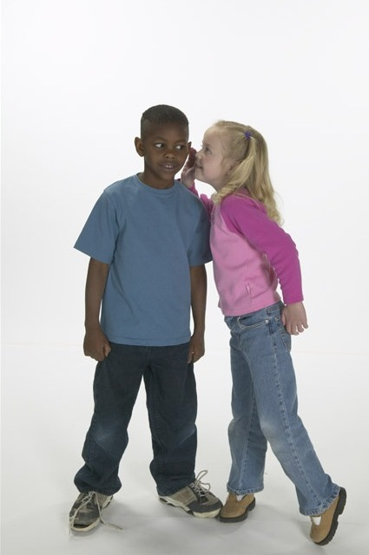

MOVIE

Title: The Great Gilly Hopkins
Genre: Comedy, Drama, Family
Rating: Not yet rated
Cast: Julia Stiles, Kathy Bates, Glenn Close, Octavia Spencer
Synopsis: This is an adaptation of Katherine Paterson’s Newbery Award-winning novel from 1979. Gilly, a tough 12-year-old girl, moves from one foster home to another—stirring up trouble at each one. When she lands with the strange Maime Trotter, Gilly schemes to get away but eventually realizes she’s landed in a place she loves.
Our Take: With the mischief involved, this movie will be better for older kids and preteens. By all appearances, it could lead to some good discussions about family roles and responsibilities—and why God puts us in the
families he does.

BOOK

Title: Magnus Chase
Author: Rick Riordan
Synopsis: With this book, popular
author Rick Riordan launches a new series about humans and gods—this time using the gods of Norse mythology. As is often the case in Riordan’s books, the young main character, Magnus, discovers he’s the son of a god. Now Magnus must prevent Ragnarok: the apocalyptic battle
signifying the end of the world.
Our Take: Riordan’s books introduce kids to the gods of various civilizations. There’s nothing wrong with learning mythology, but the author’s plots tend to blur the lines of reality, leaving the risk kids will think our God is just another myth, too. So we advise caution with Riordan’s series.

MEDIA MADNESS

CULTURE
& TRENDS
Valentine’s Shift February 14 is no longer just for couples, according to a survey of more than 600 women. People are planning more family- and friend-focused celebrations
rather than an evening of romance. 79 percent of respondents plan to bond with their kids on Valentine’s Day, and over 60 percent will have their celebration dinners with home- cooked meals. (marketingprofs.com)

Safe or Sorry? Vault apps store questionable texts, photos, and social media behind passwords that kids can set. The apps themselves are often hidden or disguised as
other kinds of apps. Parents can guard against this trend by utilizing app store settings to screen and approve the apps their kids download. (nytimes.com)

QUICK STATS

Born to Learn? A study involving more than 13,000 twins found that when it comes to kids’ motivation at school, genetics plays a larger role than shared environments such as parents and teachers. (news.osu.edu)

Saving Sight Forty percent of people in Britain are diagnosed with near-sightedness. Experts say that number is rising due to screen use and indoor activities. At the same time, some schools in China now teach children in large glass boxes and outdoors—and they’ve noted a reduction in myopia. (metro.co.uk)

Games, Sites & Apps

Adventure Time: Finn and Jake
Investigations
This point-and-click game, available on
numerous platforms, is based on the Cartoon Network’s popular
Adventure Time TV show. Players “live” in five episodes, solving fun logic puzzles.

Children’s Book Site
This site from the British newspaper is geared
toward kids and their families. Children age 7 and younger can review books with their families. Kids older than 7 can join the site with parental permission. There’s also an option for joining the site as a group. Go to http://www.theguardian. com/childrens-books-site.
Zap Zap Math
This is a free math app for students in kindergarten through sixth grade. It’s graphically appealing and features lots of higher-order thinking games so children can practice a wide range of math skills—including addition, multiplication, geometry, and fractions. It’s from the makers of Zap Zap Fractions.
This page is designed to help educate parents and isn’t meant to endorse any movie, music, or product. Our prayer is that you’ll make informed decisions about what your children watch, read, listen to, and play.
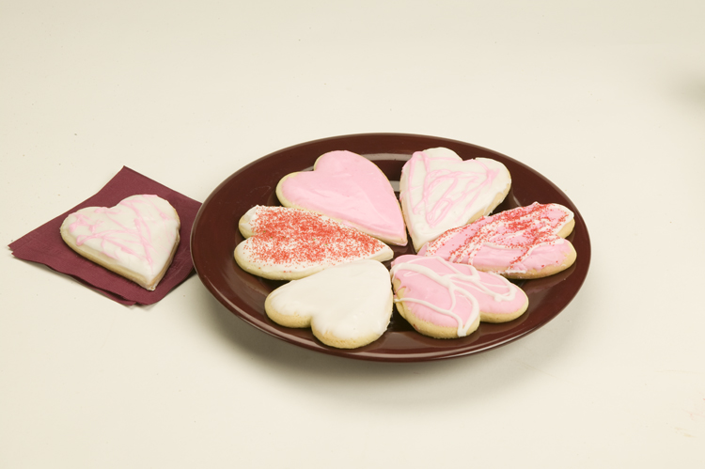

February

SUNDAY | MONDAY | TUESDAY | WEDNESDAY | THURSDAY | FRIDAY | SATURDAY
 | 1 | 2 | 3 | 4 | 5 | 6  11:00 am Sermon through Streaming (go to our church website)
7 | 8 | 9 | 10  Ash  Wednesday | 11 | 12 | 13  11:00 am Sermon through Streaming (go to our church website)
14  Valentine’s Day | 15  Presidents Day | 16 | 17 | 18 | 19 | 20  11:00 am Sermon through Streaming (go to our church website)
21 | 22 | 23 | 24 | 25 | 26 | 27  11:00 am Sermon through Streaming (go to our church website)
28

We miss the kids! When we resume meeting together again for a full service we will

be once again providing our Saturday Morning VBS/Bible Adventures’ Children’s
Program (Ages 5-12) - When we get past this period of time and are able to worship indoors again, we are planning to safely resume our Saturday morning program beginning with healthy snacks, fun activities … and getting kids into the Bible using the award-winning children’s “Hands On Bible”!

February’s Health Tip – If you love Frapuccinos and other yummy blended drinks, buyer beware! These drinks are very yummy but can pack on 400 to 1,300 calories per drink -- not to mention the saturated fat and sugar they contain. If you must indulge (which is ok to do occasionally) ... remember to view them as a treat and not a daily occurence. When ordering, you can conserve on calories and sugar by ordering a small size vs. the large size. As well, you can order your drink with a milk alternative (almond milk, coconut milk or soy milk) to further reduce sugar. If you want real milk, order with non-fat milk to reduce calories … and ask for minimal or no whip cream! ☺

