
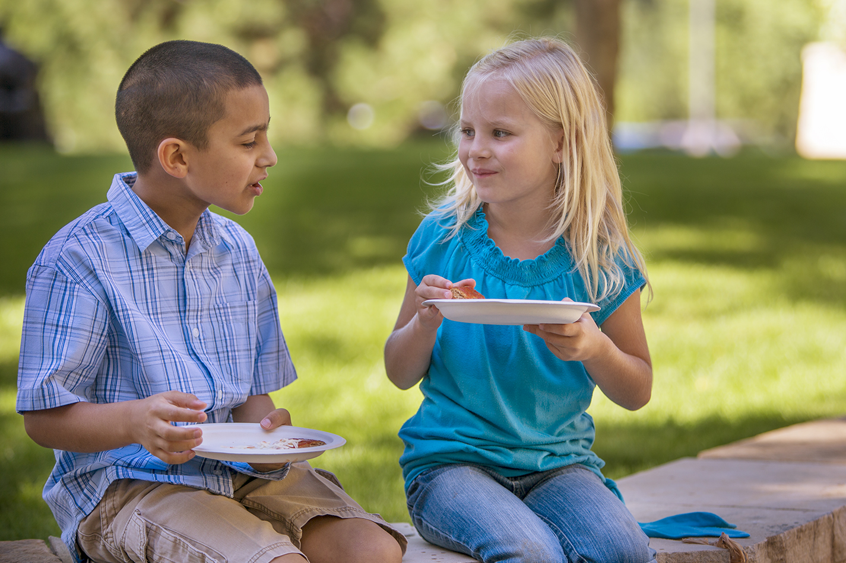

March 2020

The “Choose Kind” campaign is an outgrowth of the popular middle-grades novel Wonder by R.J. Palacio. The book addresses the tough topic of bullying, but the main message centers around the life-changing (and community-changing) power of kindness.

Treating other people with courtesy, care, and respect isn’t always our first instinct. But as followers of Jesus, we can look to him as an example of how to interact with other people—individuals created and loved by God.

Anti-bullying initiatives in schools are making some inroads at boosting kindness, yet most kids will deal with teasing and taunting at some point. Older children may be shunned from a group, known as relational bullying. Or they may face rude or even abusive behavior online, known as cyberbullying.

By emphasizing kindness from an early age, parents raise children who know how to treat people well, tell right from wrong, and enlist help if problems arise. And by explaining the biblical basis for kindness, you let kids know the true reason—and source—behind such behavior.

Kindness is key, but it’s just a start. Galatians 5:22-23 lists eight other spiritual fruits that go hand-in-hand with kindness: love, joy, peace, patience, goodness, faithfulness, gentleness, self-control. Read on to discover how your family can sow, reap, and bear the fruit of kindness!
.

x

x

Making the Choice to Be Kind


POWERSOURCE
ASK JESUS:
1. To help you be an example of kindness in all your interactions.
2. To remind your children to choose kindness in their thoughts, words, and deeds.
3. To help your family members put a stop to any bullying they may encounter.

Compliments of the
Tracy SDA Church!

www.tracysdachurch.org


TEACHABLE
MOMENTS

Kindness Counts
You’ll need ice cubes and paper towels. Have family members each share a time they’ve been kind to someone. Say: Kindness involves feelings and actions. Getting involved to help someone is the heart of kindness.
Read aloud Luke 10:30-37. Say: The priest and Levite may have been very caring guys who just happened to be too busy or scared to help. They may have felt sympathy, but only the good Samaritan expressed kindness. He set aside his own concerns to act and assist.
Give each person an ice cube and a paper towel. Have them clench the ice over the towel while taking turns sharing a worry or problem (about five minutes). Then ask: What was it like to listen closely when the ice in your hand was distracting you? How is this like putting aside our daily concerns and being kind? Say: Even when we’re uncomfortable or stressed, God will help us show kindness and compassion to others.

“Wear” Kindness Everywhere!

Has your family ever taken a challenge to engage in random acts of kindness? That’s an exciting way to bless strangers and spread joy where it’s needed most; however, kindness is meant to be much more than a random act. As Christians, we’re to strive for regular acts of kindness—habits of compassion, empathy, and selflessness that become engrained in everyday life. Colossians 3:12 uses the imagery of clothing ourselves in kindness (as well as mercy, humility, gentleness, and patience). Use these family activities to teach the value of “wearing” kindness everywhere.

God is kind to you, if you continue following in his kindness. If you do not, you will be cut off from the tree. —Romans 11:22, NCV

A Kind Touch Play a kind version of Tag, with “It” using a feather to tag people out. When someone is out, another player can give them a hug or high-five to bring them back in. Afterward, talk about the kind actions on display in the game—and how your family can put them into practice in daily life.
Seeing As God Sees Play dress-up, with a few family members in fancy clothes and jewelry, and others trying to look disheveled. Model your outfits. Then ask: “Who would you rather have as a friend? Why do we tend to treat certain people differently? Has your opinion about someone ever changed after you got to know them? Explain.” Read aloud James 2:1-5. Ask: “How does God want us to treat people, no matter what they look like? How can we change someone’s life through kindness?”

The Kindness of the Cross Have people each draw a smiley face atop a piece of paper. Say: “Pretend this is your child. Below the face, draw everything your child needs to have a loving, healthy life.” Read 1 John 3:1. Say: “Caring for someone takes effort. God, our heavenly Father, takes care of us because he loves us.” Show another paper filled with lots of angry faces surrounding a cross. Ask: “Explain whether you’d hand over your child to a mad crowd to die on a cross. God chose to do that with his Son, Jesus, so we could live in heaven with him because he cares for us.” Read aloud 1 John 4:7-10, having people stand and quickly sit at each mention of “love” or “God.” Close in prayer, thanking God for kindly sending Jesus to save us.

“Mirror, Mirror” Read Colossians 3:17. Say: “Whatever we do or say, we can represent Jesus.” Give each person an inexpensive pocket mirror. Use permanent markers to write the words of the Bible verse around the edges. Decorate the back of the mirror with words or pictures that remind you to be kind like Jesus.

Scoops of Kindness Use plastic scoops for outdoor play, or make one by cutting two inches off the bottom of milk jugs. Take turns scooping a tennis ball high in the air so another family member can catch it. Before each toss, shout out one way to show kindness to someone. Afterward, review all the examples you shared and read aloud 1 John 4:19-21. Say: “God wants us to love others, and one way we do that is through acts of kindness. We can be loving and kind to one another because God loved us first!”



MOVIE

Title: I Still Believe
Genre: Drama, Music, Romance
Rating: PG
Cast: K.J. Apa, Britt Robertson, Gary Sinise, Shania Twain
Synopsis: This biopic from the creators of I Can Only Imagine tells the true story of Jeremy Camp, a young Christian music star whose first wife died of cancer. Riverdale’s Apa stars as Camp, whose powerful experiences with love and loss reveal God’s faithfulness amid tragedy.
Our Take: For older children, preteens, and parents, this film will serve as a powerful reminder to trust God during tough times. Camp, whose hit single “I Still Believe” resulted from his personal struggles, says this movie “shows hope in the midst of pain.”
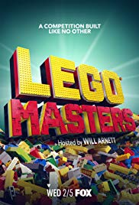
TV

Title: Lego Masters
Network: Fox
Synopsis: In this new twist on reality-show competitions, Lego fanatics race to build intricate creations to impress judges. Although contestants are adults, young viewers will be drawn to the TV series to see how the design challenges turn out. Based on preview clips, host Will Arnett injects snark and sass into his commentary.
Our Take: This appears to be a family-friendly series, and, as a bonus, each episode stands alone well. Use it to spark discussions about creativity, risk-taking, and even deadline pressure. Ask kids how they’d approach each challenge. Then have fun together with your own building blocks.

MEDIA MADNESS

CULTURE
& TRENDS
Easing Eco-Anxiety Alarming headlines about climate change cause children emotional distress, experts now say. To avoid feelings of helplessness and despair about the earth’s future, they suggest parents use age-appropriate language and emphasize taking practical steps to conserve resources. (various sources)

Crowning Achievement A growing effort to help end discrimination against black students is picking up legislative steam. California and New York recently passed the CROWN Act: Creating a Respectful and Open World for Natural Hair, which protects students from discrimination based on hair style and hair texture. (thecrownact.com)

QUICK STATS

Parental Perspectives Christian parents of minors are more likely than their kid-free counterparts to express high levels of compassion for the poor (55% vs. 48%), for criminals (13% vs. 7%), and for people who’ve wronged them (18% vs. 11%). (barna.com)

Taking Leave Though only about 16% of U.S. workers are eligible for paid family leave, more companies and states are championing that benefit. Some businesses now even offer leave for new grandparents. (hrmorning.com)

Games, Podcasts & Apps

Animal Crossing: New Horizons
The franchise’s first title for Nintendo Switch heads to a vacation setting. Players get to customize a deserted island, build a dream home, and meet all kinds of new friends. Rewards for completing milestones come in the form of Nook Miles. Rated E for Everyone.
Be Calm on Ahway Island
These calm, kid-friendly stories teach emotional regulation and self-soothing. Weekly episodes, which strive to be inclusive, are ideal for bedtime. Some may balk at the mention of meditation, but the fun exercises (such as taking “dragon breaths”) build helpful life skills.
Biba Playground Games
Outdoor play equipment becomes the site for children’s real-life “missions,” thanks to this free mobile app. By scanning augmented-reality tags in one of 5,000+ parks, players can blend digital and physical play. Reviewers say this app is a great way to get kids moving.

This page is designed to help educate parents and isn’t meant to endorse any movie, music, or product. Our prayer is that you’ll make informed decisions about what your children watch, read, listen to, and play.

March

SUNDAY | MONDAY | TUESDAY | WEDNESDAY | THURSDAY | FRIDAY | SATURDAY
1 | 2 | 3 | 4 | 5 | 6 | 7  10:45 am –VBS/Bible Adventures Program (Ages 5-12)
8  Daylight-Saving Time Begins | 9 | 10 | 11 | 12 | 13 | 14  10:45 am –VBS/Bible Adventures Program (Ages 5-12)
15 | 16 | 17  St. Patrick’s Day! | 18 | 19 | 20 | 21  10:45 am –VBS/Bible Adventures Program (Ages 5-12)
22 | 23 | 24 | 25 | 26 | 27 | 28  10:45 am –VBS/Bible Adventures Program (Ages 5-12)
29 | 30 | 31

Saturday Mornings VBS/Bible Adventures’ Children’s Program (Ages 5-12) Each Saturday morning beginning at 10:45 am until 12:00 noon, our Bible Adventures program is designed to introduce kids to God in interactive and engaging ways through the Bible – not to
mention they have lots of fun! Each week’s themed program includes singing, team activities,

healthy snacks and getting kids into the Bible using the award-winning children’s “Hands On Bible”!
Parents/Guardians are also invited to observe the program anytime, and if you would like more information about our Bible Adventures’ Program or volunteering (let us know!), please contact Kimberly at 209-481-9205.
Free Nursery Care and Toddler Program – Every Saturday during our 11:00 am church service!
March’s Health Tip – March is the start of a new, healthy month as we move into spring and warmer weather. Below are some healthy tips for the family from Nourish Interactive!
- Today make over your fridge and throw out the junk.
- Set a timer to remind kids to take an activity break away from the computer after 20 minutes.
- Teach your children that they need to wash their hands for 20 seconds. Have kids lather up with soap to kill bacteria.
- Share a story about your favorite green veggie or fruit.
- To avoid muscle injury, teach your kids to stretch their muscles before and after they exercise.
- Have your children find as many different colors of vegetables in the grocery store.
- Try some kiwi for a tasty green snack!
- Decorate your plate with the colors of the rainbow.
- Children and teens need 1 hour of exercise each day to helps their growing bones, heart and overall health.
- Cashews, almonds, walnuts, pecans, and peanuts have heart healthy oil. It makes a great after school snack. One ounce if nuts is equal to one serving of meat.
- You can make French fries healthier by making baked French fries.
- Look for whole grain cereals and breads with at least 4 gram of fiber.

